**SOLANO COMMUNITY COLLEGE**

**MT 162, ROBOTICS**

Fall, 2018

SOLANO COMMUNITY COLLEGE

ROBOTIC SYSTEMS MT-162

**LAB 6: MOTION INSTRUCTION PROGRAMMING PT. 2**

**Catharine Crayne**

**10/22/18**

**OBJECTIVE**:

1. To learn how to create, teach, test, and execute a motion program that use various types of instructions and creates a variety of motion shapes.

**Group Members**

N/A

**MATERIALS**: RoboGuide and Laptop, Fanuc Robot, Box

**PROCEDURE**:

1. Power up the robot controller. Place the robot and pendant in Teach Mode.
2. Set the active Frames to Tool 2 and User 0. Remember [SHIFT] + [COORD].
3. Verify Tool Frame 2 is taught correctly by Jogging the robot in TOOL, yaW, Pitch, and Roll. If it is not correct, re-teach it.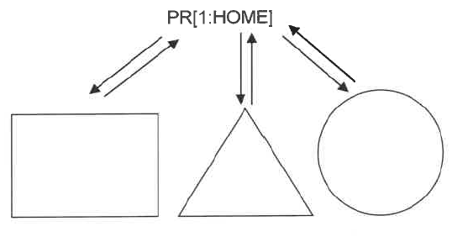
4. Set the robot to jog in JOINT coordinates.
5. Make sure the robot has a Position Registers for HOME.
6. Create a new program, “SHAPESLab6YourName”.
7. Include the USER Frame and TOOL Frame info in the first couple of lines.
8. Have the program go to the HOME PR position with a Joint move.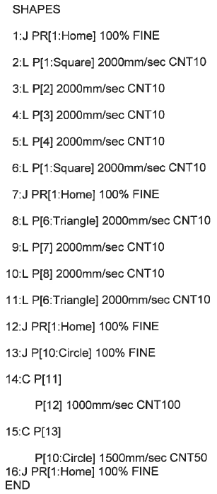
9. Then program the robot to trace a square, triangle, and circle, returning back to HOME in between each. See example to the right..
10. Test your program in STEP mode.
11. Now test the program in continuous mode.
12. Now turn off the Teach Pendant, set the Operator Panel to AUTO, and run your program in AUTO mode.
13. Now Copy the Program and name it “SHAPESRLab6YourName”.
14. Edit this program and use the copy and paste functions to reverse the motion of the program. Test and verify its operation.

**RESULTS - DATA**

No Procedure questions were included in this lab.

**OBSERVATIONS**

Step 2 Step 8

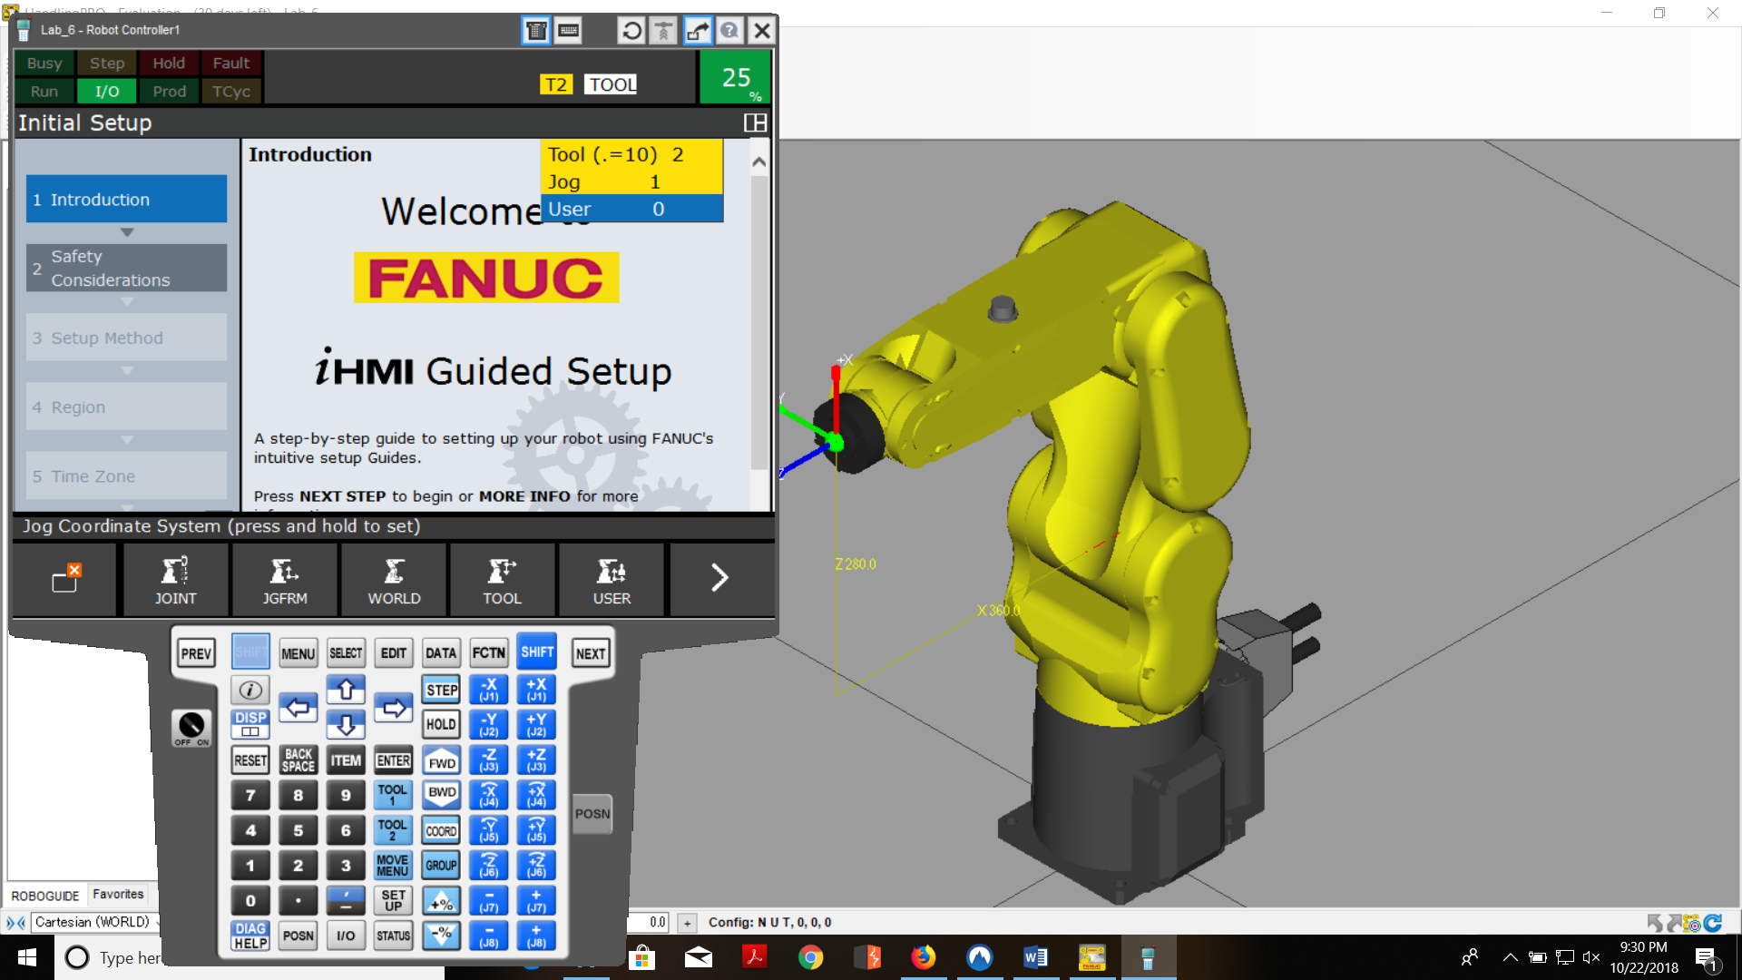 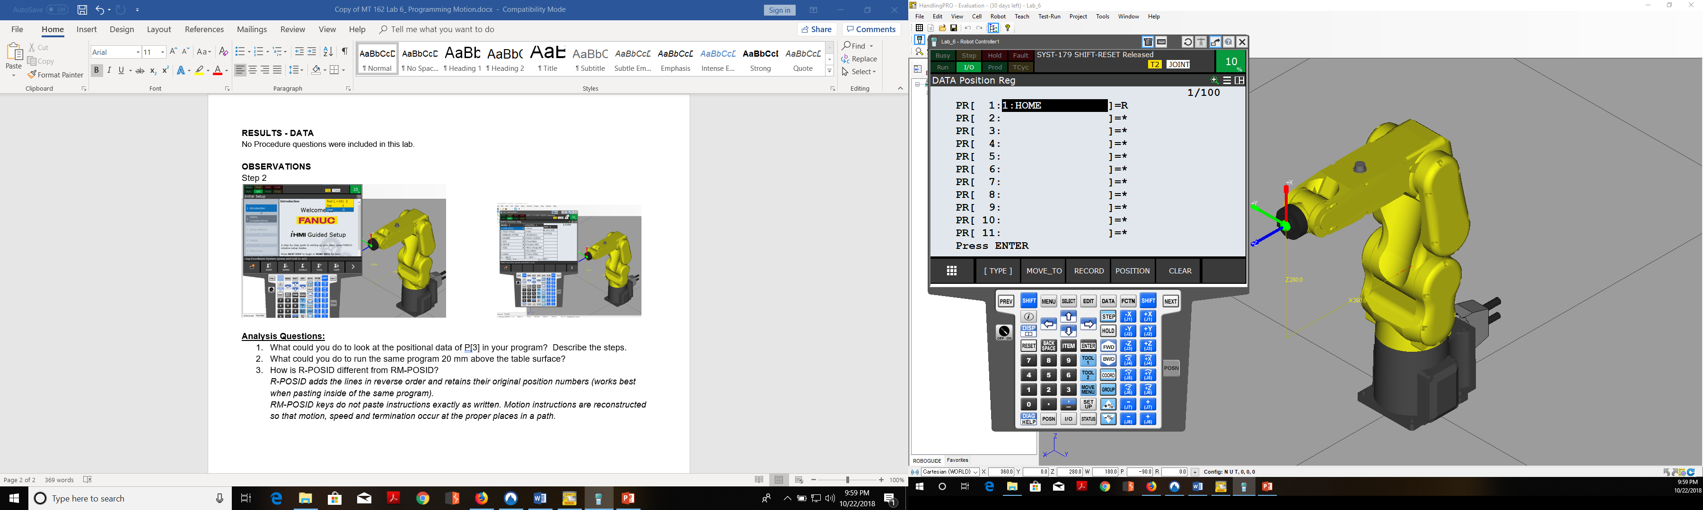

Step 9 Step 9

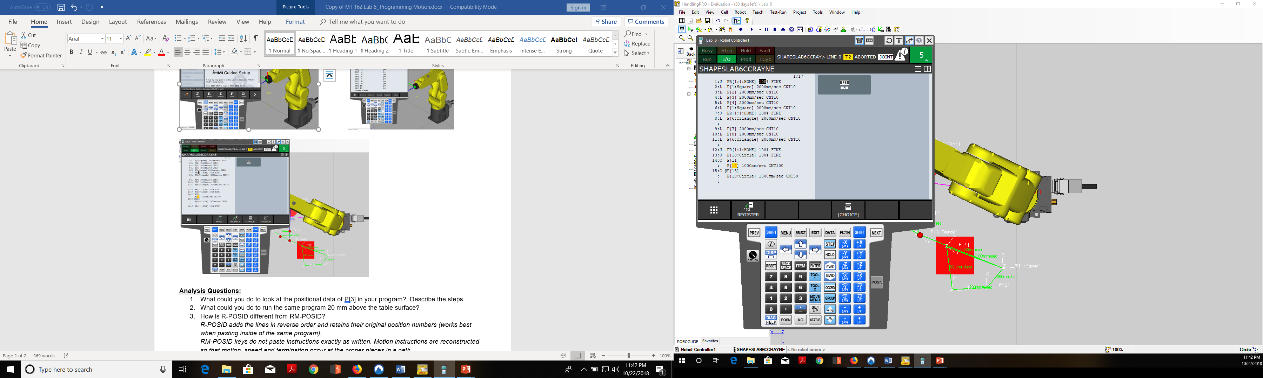 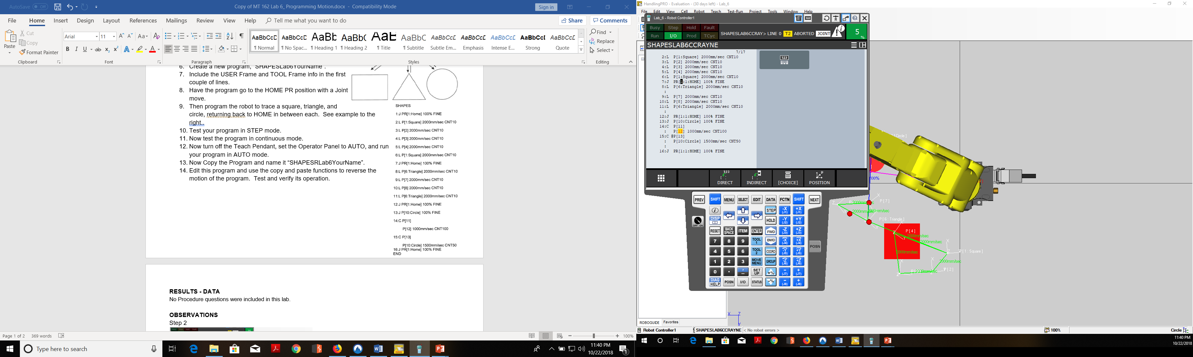

Step 13 Step 14 Step 14

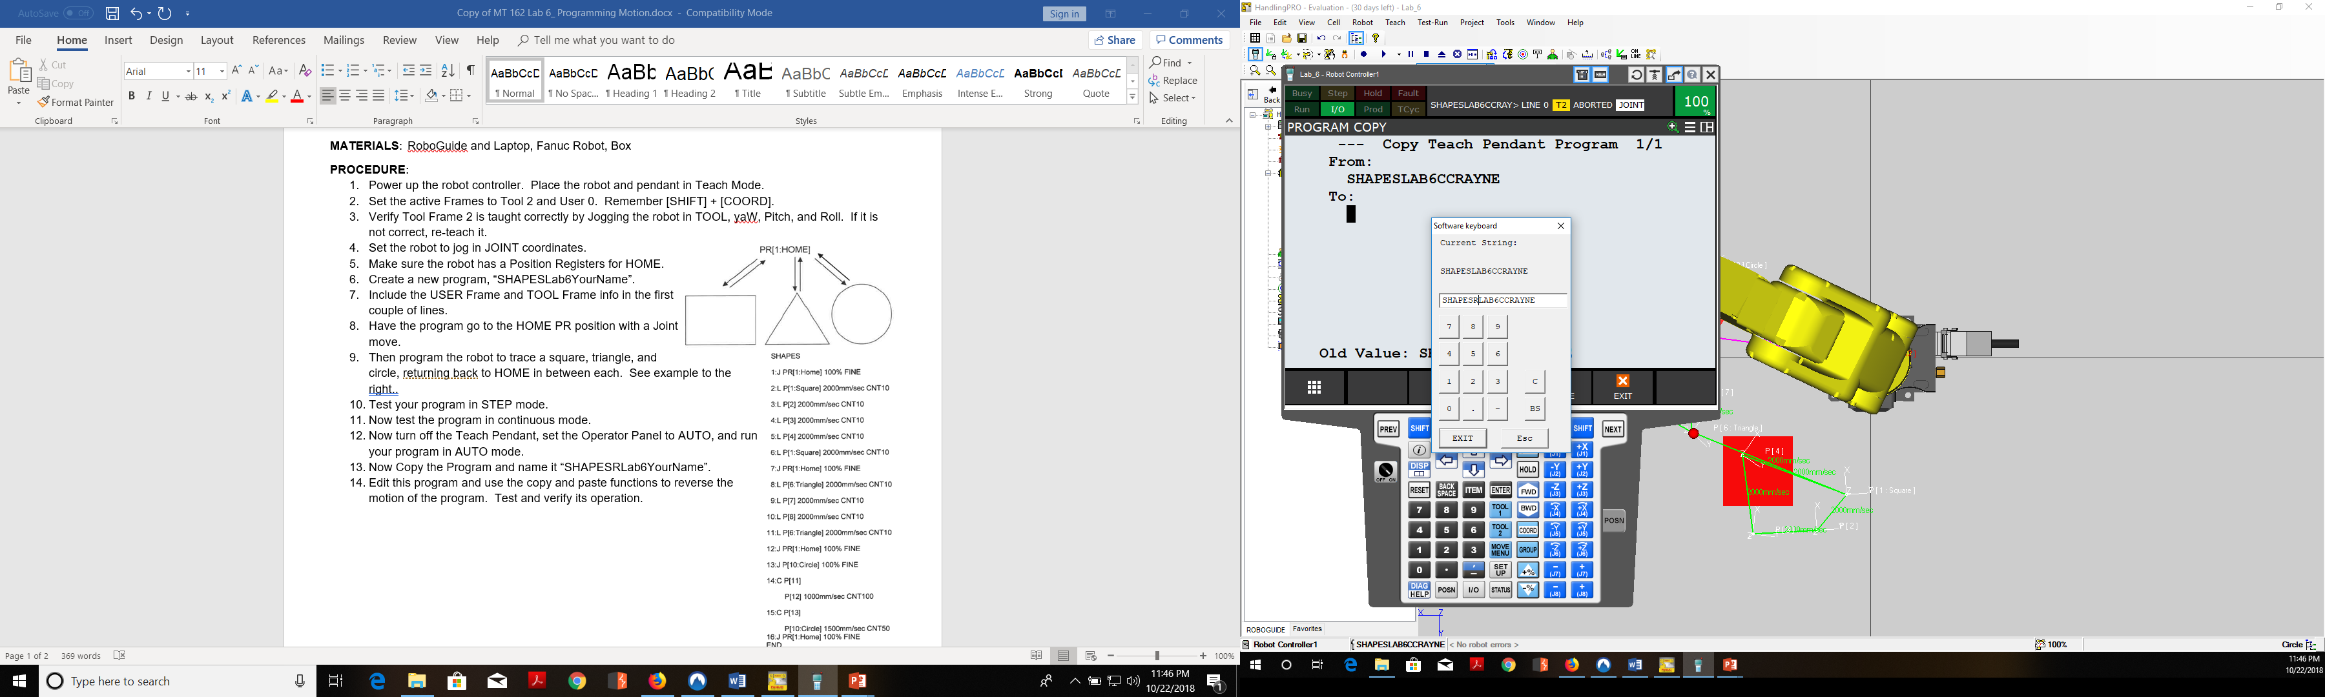 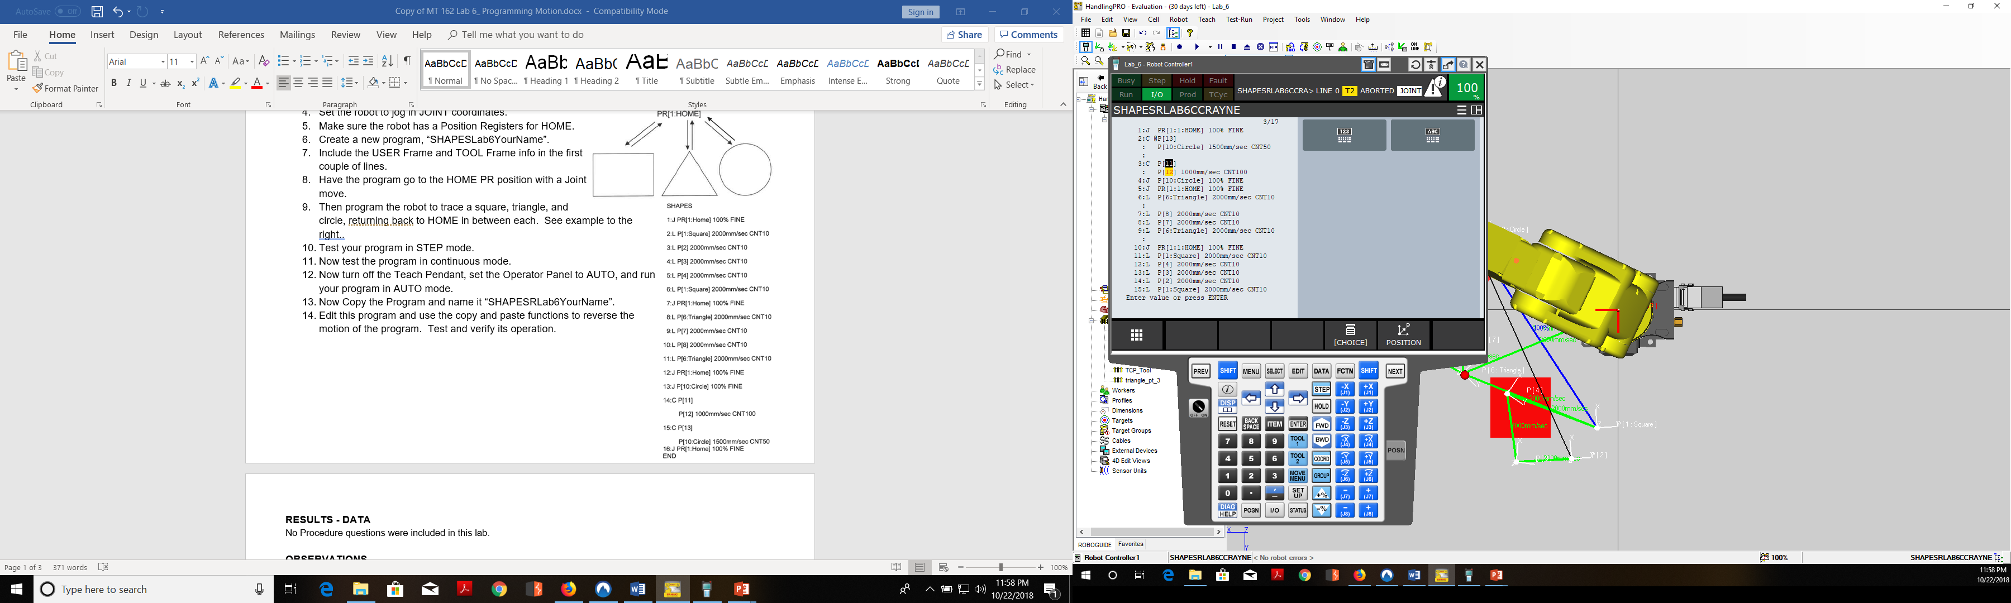 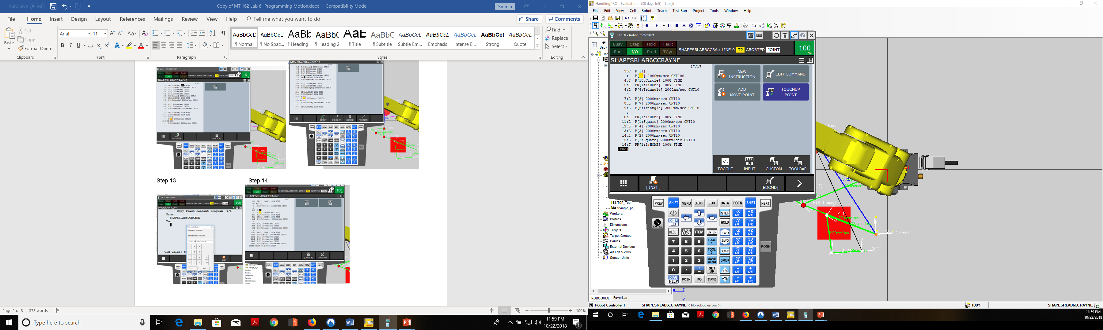

**Analysis Questions:**

1. What could you do to look at the positional data of P[3] in your program? Describe the steps.
2. What could you do to run the same program 20 mm above the table surface?
3. How is R-POSID different from RM-POSID?

*R-POSID adds the lines in reverse order and retains their original position numbers (works best when pasting inside of the same program).*

*RM-POSID keys do not paste instructions exactly as written. Motion instructions are reconstructed so that motion, speed and termination occur at the proper places in a path.*